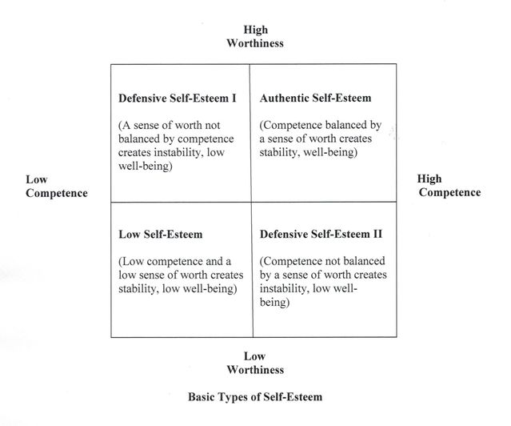
Mruk’s Model of Self Esteem

