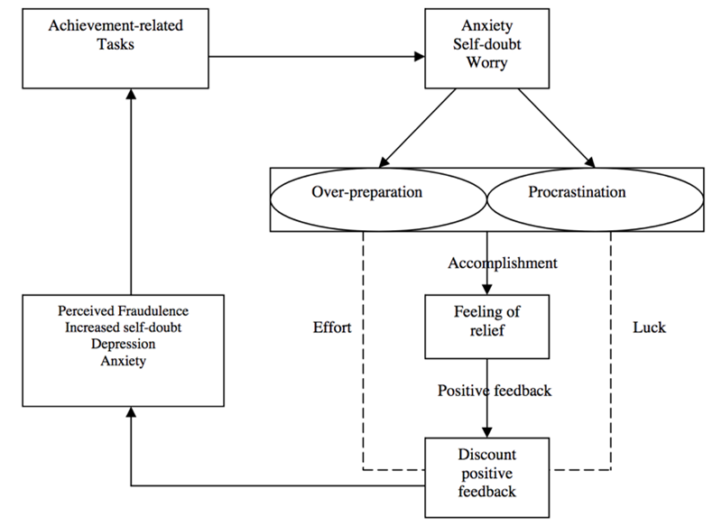
Clance, & Imes (1978) The Imposter Phenomenon

